# **PROJECT #5**

# **Client/Server Architecture Using A MySQL Relational Database Management System (MySQL RDBMS)**

## **Understanding Client-Server Architecture**

**Client-Server** Refers to an architecture in which 2 or more computers are connected together over a network to send and receive requests between one another.

Generally, the client sends requests to the server and receives requests from the server as well. A **client** can also be your laptop, or the browser on your laptop, while the **server** is the remote computer that the website is running on (It could be a Linux Distro like Ubuntu OR WINDOWS SERVER).

Send a request from **client** (Linux Terminal) with the curl command below

$ curl -Iv www.propitixhomes.com

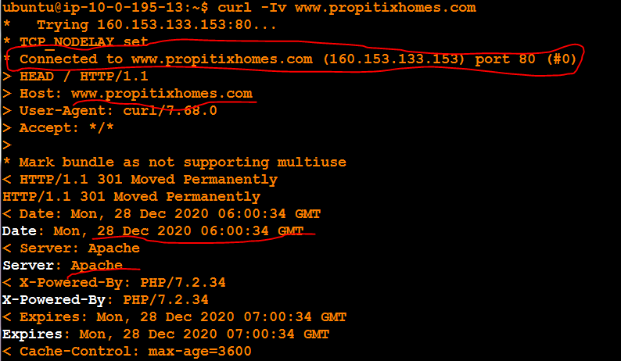

1. On mysql server Linux Server, using apt, install the MySQL software.

I used the command **$sudo apt install mysql-server ……(10.0.171.184).**

1. With the command **$sudo mysql -u root -p** ………..and the password, to verify and login into Database. And exit.

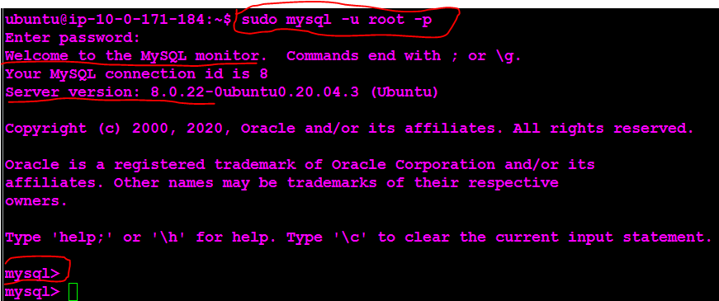

1. On mysql client Linux Server, using apt, install the MySQL client software

I used the command $**sudo apt install mysql-client………(10.0.77.136.)** I run the command ifconfig and I do not the ip-address. So to find the IP address i installed the net.tools with the command **$sudo apt install net-tools.** And with **$ifconfig** i get the ip address.

B. With the command **mysql -h ip-address -u root -p** ………..and the password,i got an error. **NOTE =ip address of the mysql-server**

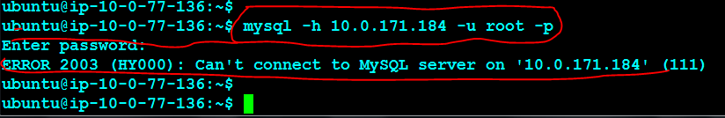

**I**t is normal to get errors above. Let's fix it.

1. On mysql client Linux Server, connect remotely into the mysql server Database Engine without using SSH. You must use the mysql utility to perform this action.

**HOW TO ALLOW DATABASE SERVER FOR CLIENT TO CONNECT successfully.**

For the MySQL server and clients to communicate with each other over a private network, then the best option is to set the MySQL server to listen only on the private IP of the client. To do this, I edited the MySQL configuration file in mysql-server and changed the value of the **bind-address option to the ip address of client server or 0.0.0.0 to anywhere**. so I set the IP address to anywhere in this case. The location of the MySQL configuration file is located at /etc/mysql/mysql.conf.d/mysqld.cnf

$cd /etc/mysql/mysql.conf.d

**$sudo vi mysqld.cnf** Open the file with text editor.

Search for a line that begins with **bind-address** and sets its value to the IP address on which a MySQL server should listen to 0.0.0.0 or client IP address range.

By default, the value is set to 127.0.0.1 (listens only in localhost). Change to 0.0.0.0 = bind-address = 0.0.0.0 and save.

D. Once done, I restarted the MySQL service for changes to take effect. Only root or users with [sudo](https://linuxize.com/post/sudo-command-in-linux/) privileges can restart services.

**$sudo systemctl restart mysql.**

**E.** in the Client server

Run **mysql -h ip-address -u root -p** ………..and enter the password, to verify login into Database. **NOTE =ip address of the mysql-server.** Another Host error will show.

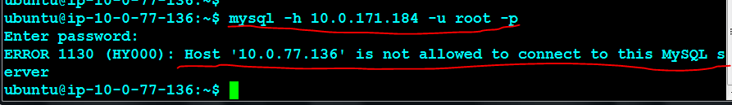

By default the **Database server** does not allow Root login. So I need to create a USER. login my **mysql** and create that user. **$sudo mysql**

**mysql> CREATE USER 'lawrence'@'database ip address' IDENTIFIED BY 'Law55231';**

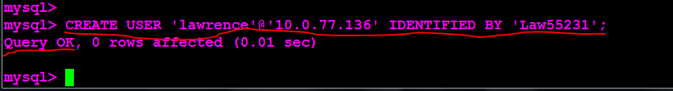

**In the client server run, ……….$mysql -h ip-address -u lawrence -p** ………..and enter the password, to verify and login into Database. **NOTE =ip address of the mysql-server..**

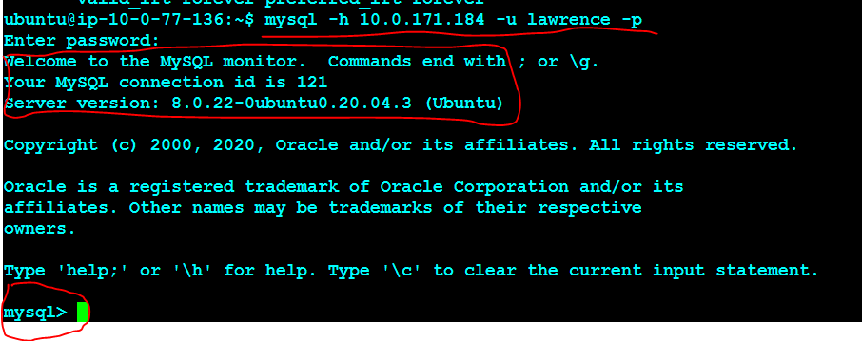

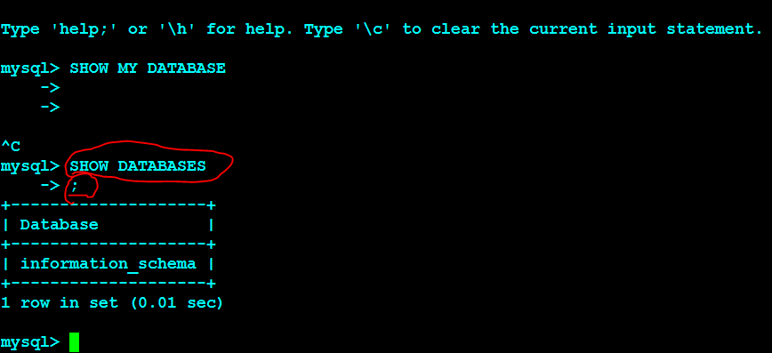

**Summary:**

**The concept of the ip-address of both machines is very important.**

**In the real world, never open the database ip-address to 0.0.0.0**

Source [How to Allow Remote Connections to MySQL Database Server](https://linuxize.com/post/mysql-remote-access/):

source:[How to Create MySQL Users Accounts and Grant Privileges](https://linuxize.com/post/how-to-create-mysql-user-accounts-and-grant-privileges/#before-you-begin)